(Appendix 2)
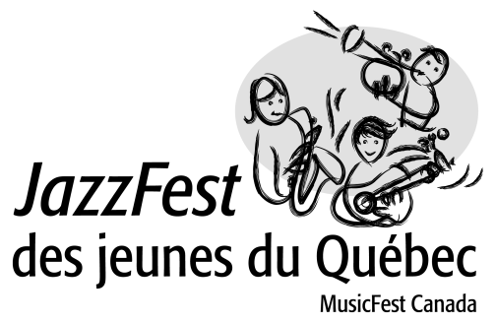

CONSENT FORM FOR MINORS
(parental permission)

1. I hereby authorize the distribution of any image or video of my minor child, in whole or in part, individually or with other images or videos by the Conseil québécois de la coopération et de la mutualité (and on the various media platforms associated with it) and on other official sites, as well as for media purposes, including promotional presentations and advertising campaigns. I also authorize the distribution and use of any media material created by my child on behalf of the Conseil québécois de la coopération et de la mutualité.

2. I waive my right to privacy and any compensation to which I may be entitled in connection with the use of my child's name, including rights to a written copy arising from the production, modification and promotion of a video.

3. I am the parent or legal guardian of the child and I have read and familiarized myself with the contents of this form.

Name of Parent or Guardian

(please print):

Signature:

Child's name:

Date:

